Nama : Rizki Nur Fauzi

NIM : 18090054

Kelas : 5B

**PRAKTIKUM 1**

1. Source Code

Kenalan.php -> application/controller

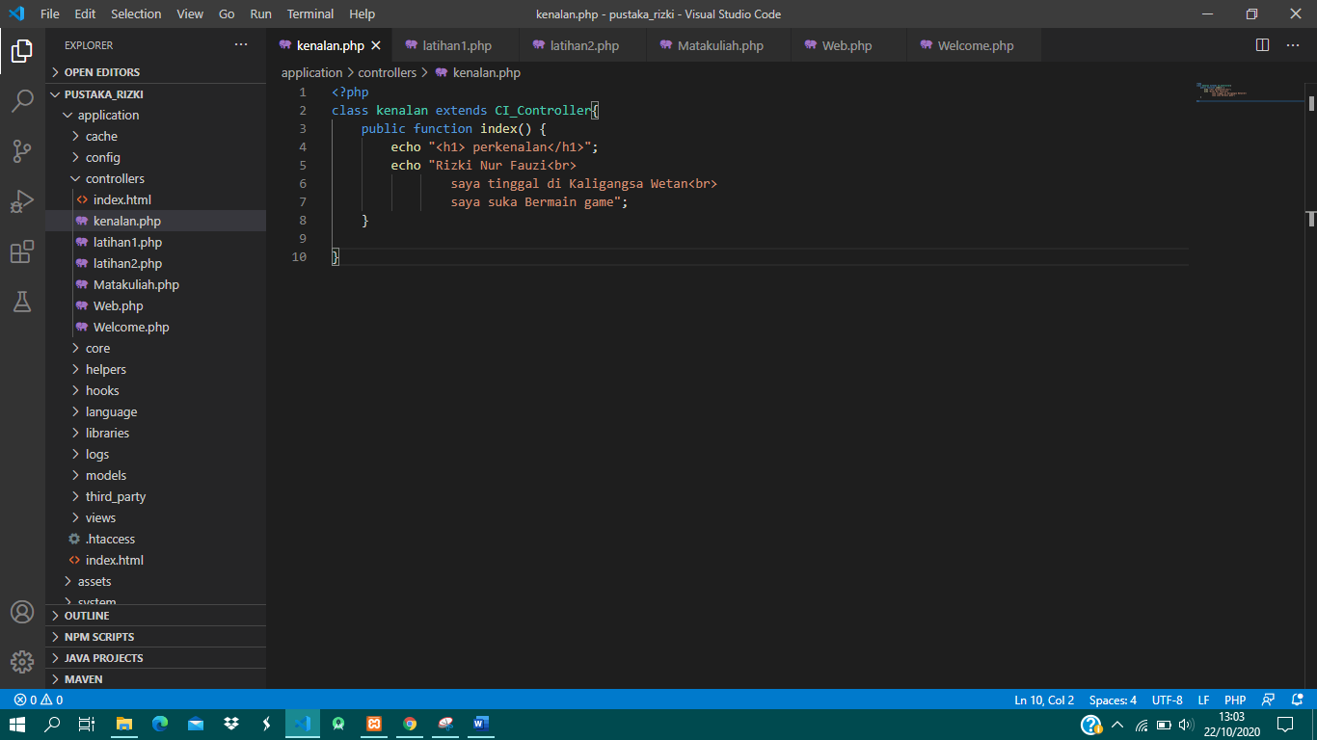

1. URL

htt://localhost/pustaka_rizki/index.php/kenalan

1. Capture Hasil

